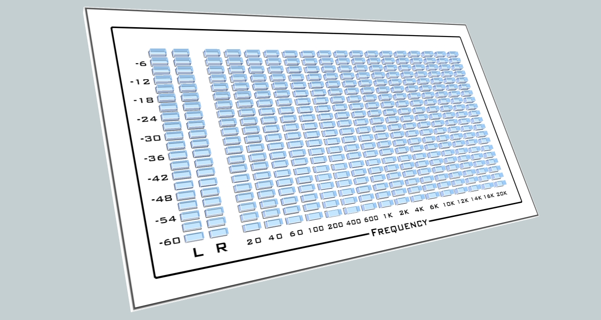
Open SA

Project name:

Open SA – the open source audio spectrum analyzer (temporarily named)

Functional descriptions of desired functionality
The goal of this project is to have a software API that will work as an arduino 1.0 or greater library. The main objective the library will need to accomplish is driving the 18x20 led grid and several modes of operation.

The front end will be an arduino sketch (*.pde) which will allow the user to toggle through the different modes via a button press.

Modes:
0. Startup sequence-
1. Some sort of pattern to show that all leds are operational upon a power up, either diagonal or left/right sweep

- Standard –
  - 'L' shows voltage of left channel scaled 0-5V, 0-20 LED row indicated
  - 'R' shows voltage of left channel scaled 0-5V, 0-20 LED row indicated
  - 16 Frequency channels show the normal FFT response, 0-20 each row
(possible to sum the L + R channels for FFT analysis?)
- Left only –
  - Flash “L”, as letter on the LED grid
  - Display the Left channel audio scaled on 'L' and 'R' channels
  - FFT is computed with only left audio and displayed on 16 channels
- Right only –
  - Flash “R”, as letter on the LED grid
  - Display the Right channel audio scaled on 'L' and 'R' channels
  - FFT is computed with only right audio and displayed on 16 channels
- FFT + 2
  - Same as standard but adds a dot above the normal value for each channel
e.g. 111111111101 , 1'S on LED
11111111111101
- Dot mode -
  - Same as standard but instead of filled columns, only the highest valued led of the column is on
- Trickle mode -
  - Same as standard but the peak value will trickle down with a delay to the current value. (shown in video)
- Horizontal VU -
  - Display Left and Right audio throughout the grid horizontally
top 10 rows down are left audio, lower 10 are right audio
- Rain -
  - Some sort of matrix, rainy effect. Your discretion
- Text -
  - Allows scrolling of text, for twitter feed, email or time
- Misc – I'm open to any suggestions

Relevant hardware schematics
Will be provided.

Microcontroller part number
Initial project will be done with the Atmega2560 arduino compatible board.
Specifically the project mates with this board → https://www.sparkfun.com/products/11007

Prototype hardware for development (if necessary)
Will be provided.

General timeline and target dates

Flexible, looking for a first stage completion in 3-4 weeks.

What I'm looking for at completion:

At the end of the project I expect to have a folder (probably named OpenSA) where I can paste it into the libraries folder of my Arduino install, and have it work and operate just as any of the other standard library.
I would also expect to have an example sketch within the folder that performs the button press cycling of the modes.

In addition:

I would also be receptive to any sort of suggestions you may have regarding functionality of the software or any hardware changes you think may be necessary. The project is only in the beta stage so I'm sure there will be changes that need to be made.

Helpful software packages:  http://learn.adafruit.com/piccolo  http://learn.adafruit.com/adafruit-led-backpack  http://learn.adafruit.com/timesquare-watch-kit | Helpful samples:  http://www.youtube.com/watch?v=w9uCCSE4KBo  http://www.youtube.com/watch?v=LIOUXr9v2RI

Current prototype:
